Sample
Page 1 of 2
Medical Undertaking for members joining FBS AIOS (for all ages)
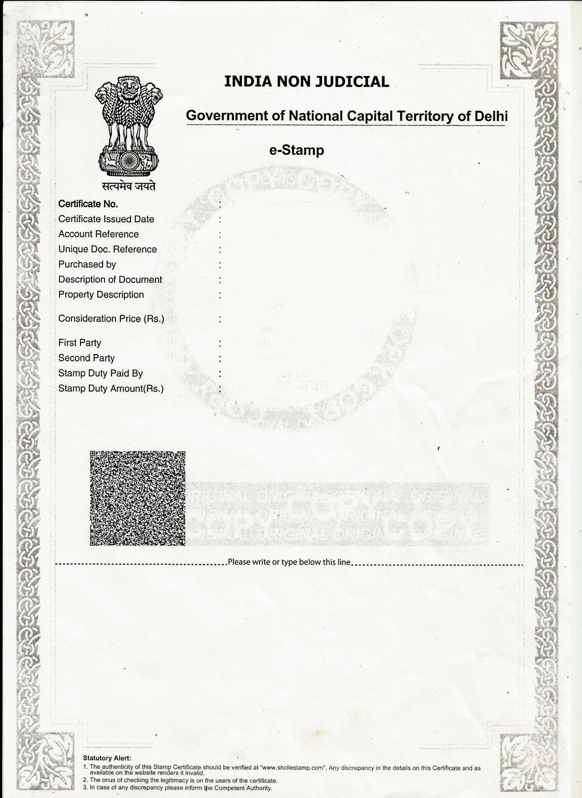
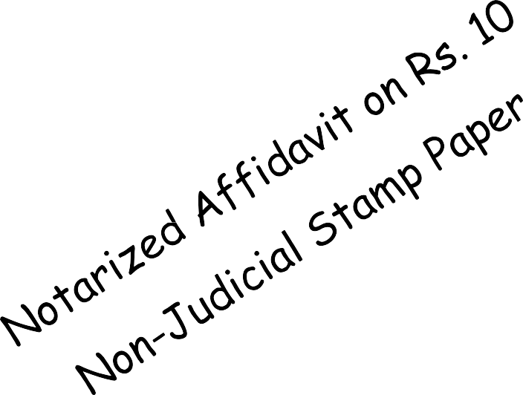

Page 2 of 2

I undersigned Dr. , son / daughter of , age years, working as an , residing at
, in sound mental and physical health and no duress, do hereby solemnly affirm that,
I am a life member of All India Ophthalmological Society (AIOS), with an allotted AIOS membership number .
My date of birth is (dd-mm-yyyy), (in words).

I Dr. , have no evidence or symptom of any acute or chronic terminal mental or physical illness. I have never had any severe life threatening illness of heart, kidneys, brain, liver, lungs, cancer, or metastasis of cancer or any other terminal illness. No major / big operation has ever been performed on my body for any such illness or disease. I am not suffering from any other critical, advanced or terminal illness.
I have executed this affidavit to submit before the society of Family Benefit Scheme for the members of All India Ophthalmological Society (herein called as the “SOCIETY”).
I am fully aware that making a false affidavit is a criminal offence, and at any date or event, any of my above mentions or claims are found to be false, my membership of the society of Family Benefit Scheme for the members of All India Ophthalmological Society shall be terminated immediately, and myself and my nominees shall not be considered for any benefit from the society.
The above stated facts are true and correct to the best of my knowledge and belief.

Place: Deponent: _

(signature)

Date: / / (dd-mm-yyyy)

Fingerprint:

